SOCIAL MOOD MATCHER
AI-Powered Social Media Caption & Hashtag Generator

TEAM MEMBERS
YOGESH M
GURUPRASHATH M
AARYA S S
LATHEEF K

1. Introduction
Social media platforms require engaging captions and relevant hashtags to improve visibility and audience engagement. However, creating captions manually for every post is time-consuming and often inconsistent.
The Social Mood Matcher project is an AI-powered system that automatically generates captions and hashtags based on the mood and context of an uploaded image.
The system uses advanced AI models:
- BLIP for image captioning
- DistilBERT for sentiment analysis
- Gemini 2.5 Flash (optional) for enhanced caption generation
The generated content is automatically optimized for different social media platforms such as Twitter/X, Instagram, and Facebook.

2. System Workflow (Output Step Process)
The Social Mood Matcher system follows a step-by-step workflow to process images and generate captions.
Step 1: Application Interface
When the user launches the application, the Streamlit user interface is displayed.
Users can upload an image and select the desired caption style and platform.
Features available in the interface:
- Image upload option
- Caption style selection
- Platform selection
- Hashtag count adjustment
- Gemini AI toggle option
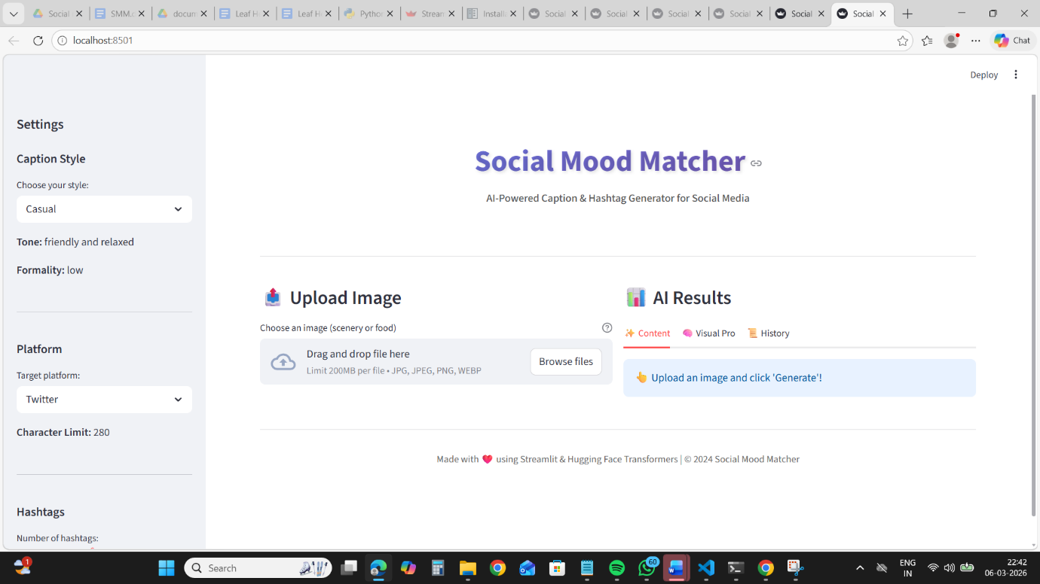
Fig 1.1 Main Application Interface

Step 2: Image Upload and Preview
The user uploads an image (JPG, PNG, or WEBP format).
The system validates the image and displays a preview before processing.
Functions performed in this step:
- Image validation
- Image resizing
- Thumbnail preview generation
- File size verification (Max: 10MB)
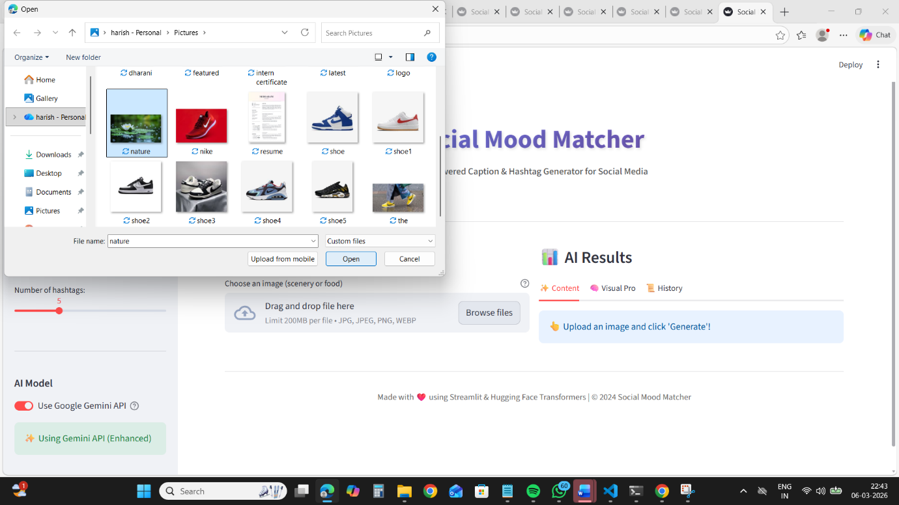
Fig 1.2 Image Upload & Preview

Step 3: Image Analysis using AI Models
After the image is uploaded, the system analyzes the image using BLIP to generate a visual description.
Example output:
"A water lily in a pond"
This caption represents what the AI understands from the image.
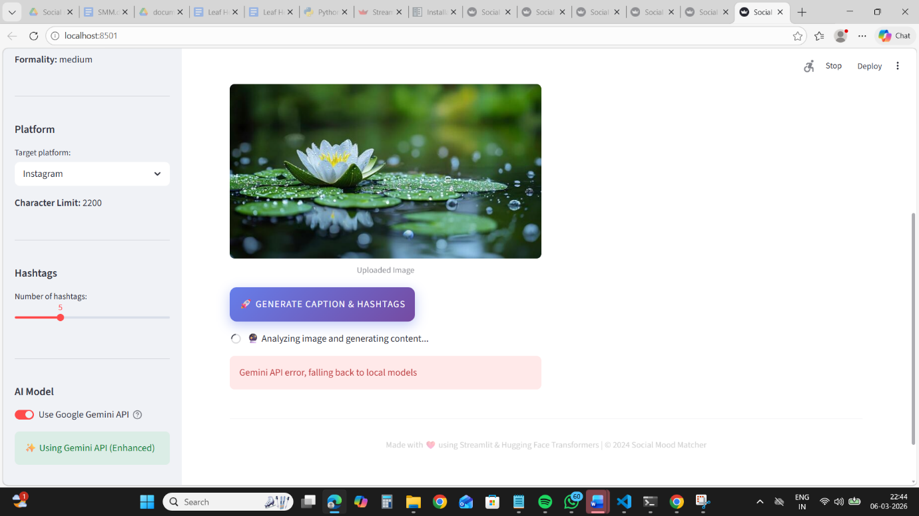
Fig 1.3 Image Caption Detection

Step 4: Sentiment Detection
The generated caption is passed to the DistilBERT sentiment model to determine the emotional tone of the image.
Possible detected moods include:
Happy
Cozy
Calm
Aesthetic
Romantic
Energetic
Nostalgic
Luxury
Peaceful
Adventurous

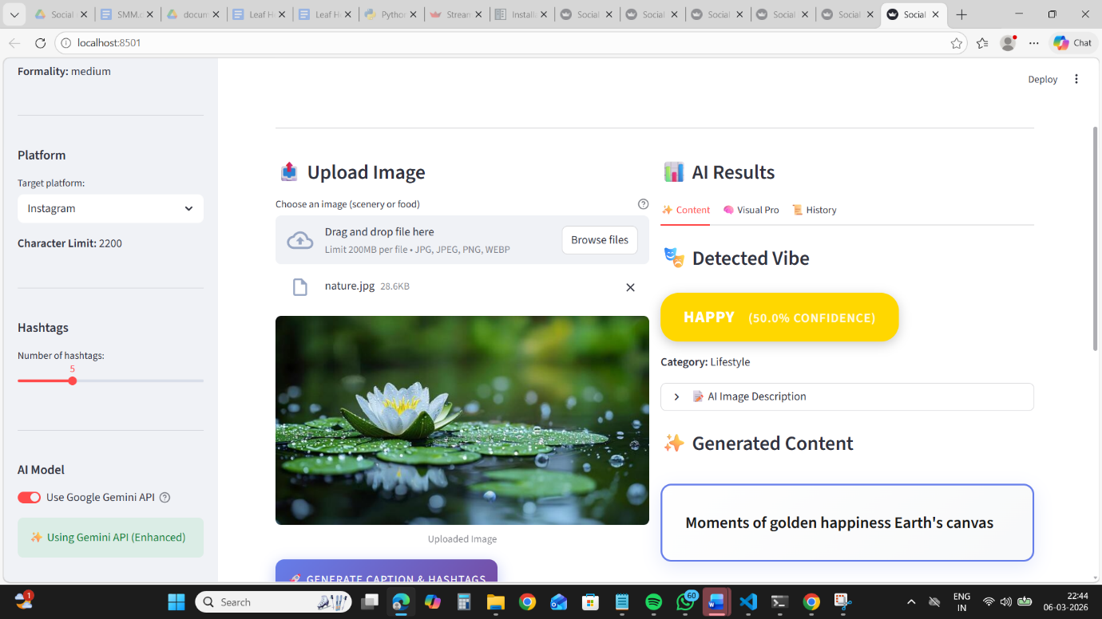
Fig 1.4 Sentiment Detection Output

Step 5: Caption Generation
Based on the detected sentiment, the system generates captions according to the selected caption style.
Available caption styles:
Style Description
Casual Friendly and relaxed
Aesthetic Artistic and poetic
Professional Formal and informative
Playful Fun and energetic
Example generated captions:
Casual:
Nothing beats a warm bowl of homemade soup on a chilly evening.
Aesthetic:
Comfort served in every spoonful.
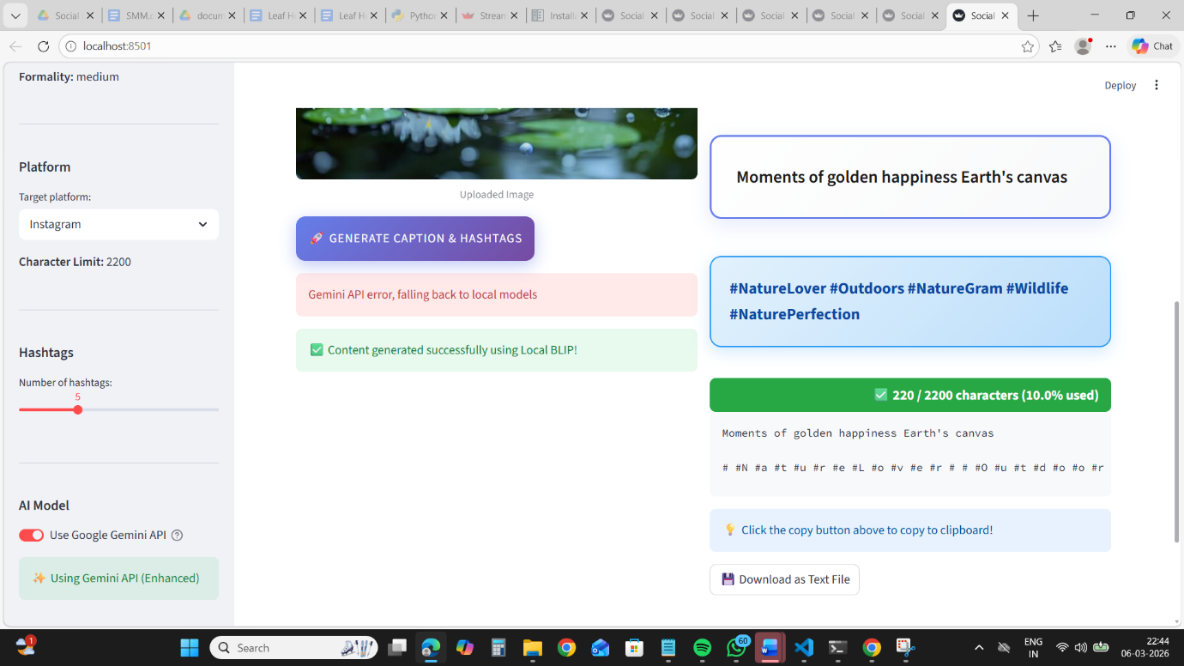
Fig 1.5 Generated Caption

Step 6: Hashtag Generation
The system generates trending hashtags based on:
- Image category
- Sentiment
- Popular social media trends
- Example hashtags:
- #FoodPhotography
- #ComfortFood
- #CozyVibes
- #Homemade
- #Foodie
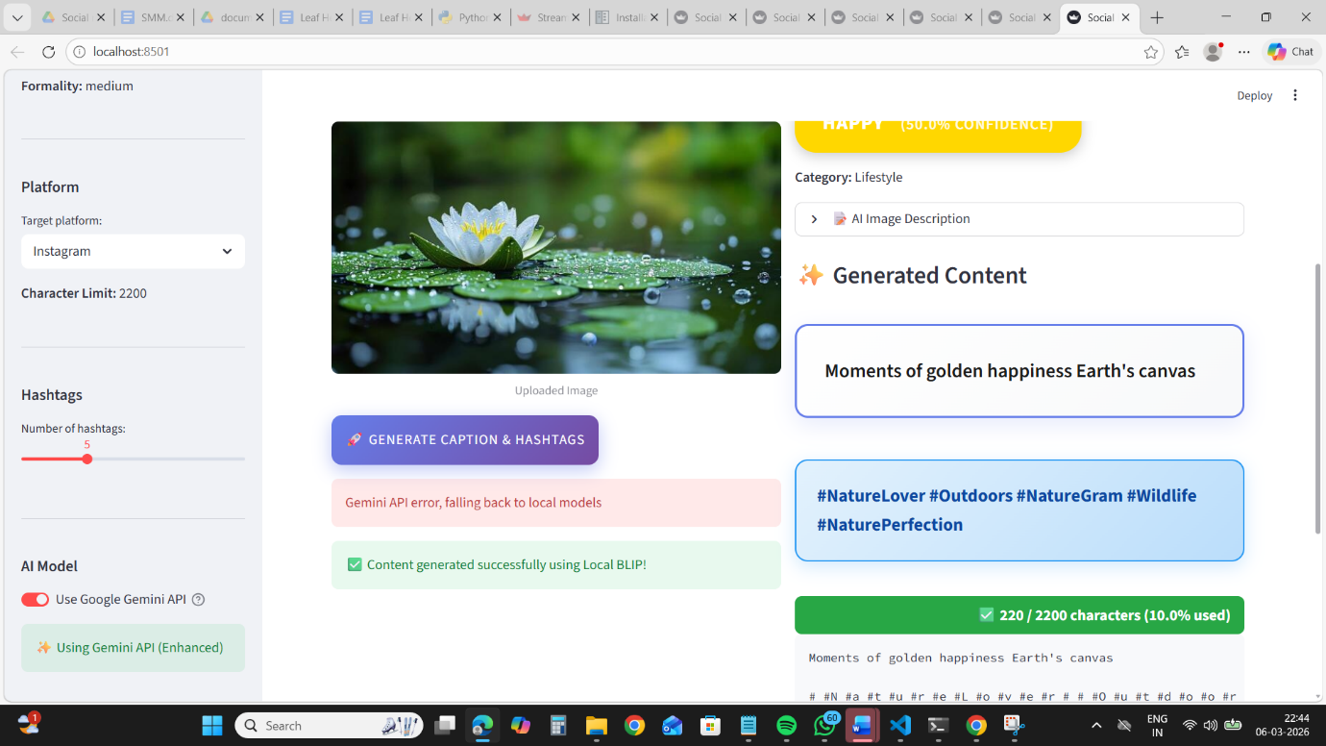
Fig 1.6 Hashtag Output

Step 7: Platform Character Limiting
Each social media platform has different character limits.
Platform Character Limit
Twitter/X 280
Instagram 2200
Facebook 63206
The system automatically ensures that captions and hashtags remain within the allowed limits.
If necessary, hashtags are truncated while keeping the caption intact.
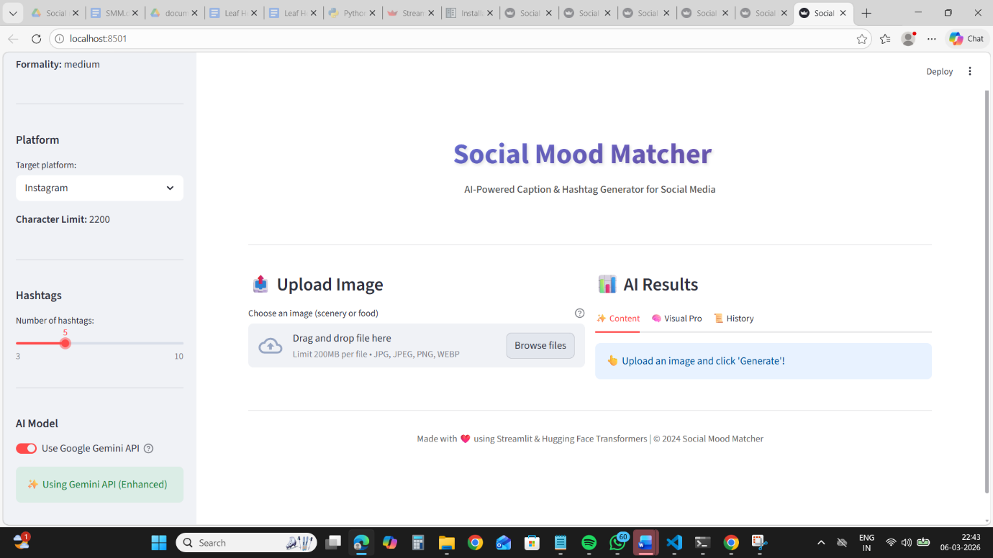
Fig 1.7 Character Limit Display

Step 8: Final Output Display
The final output includes:
- Generated caption
- Suggested hashtags
- Character count
- Sentiment result
The user can copy the content or download it.

Fig 1.8 Final Output Screen

Step 9: Export and Download
The generated content can be exported in different formats:
- Text file
- Word document
- PDF file
- This allows users to easily reuse captions across multiple platforms.

3. System Architecture
The Social Mood Matcher system follows a modular architecture.
Components include:
Component Function
Streamlit UI User interaction and display
Image Sentiment Detector Image understanding and mood detection
Caption Generator Creates captions based on sentiment
Hashtag Engine Suggests trending hashtags
Character Limiter Ensures platform compatibility
Gemini AI Layer Optional advanced caption generation
4. Technologies Used
Technology Purpose
Python Backend development
Streamlit Frontend UI
BLIP Image captioning
DistilBERT Sentiment analysis
Gemini API Advanced AI generation
Transformers AI model integration
Pillow Image processing
Python-DOCX Word export
ReportLab PDF generation

5. Conclusion

Social Mood Matcher simplifies social media content creation by using AI to analyze images and generate captions automatically.The system combines image understanding, sentiment analysis, and generative AI to produce engaging social media content tailored to the mood of the image.By automating caption creation and hashtag selection, the platform helps content creators save time while improving engagement on social media platforms.

